## Ideas for your career

Do you know, what you want to do after finishing school? If your answer is “Yes”, then you can stop reading now. Everyone else is invited to read this article, you may get some idea of shaping your future. There are a couple of options:

First, you can get a job, of course. As a graduate from any technical college, various doors will open for you, so it shouldn’t be a major problem getting hired somewhere. Safe options are to begin as a software developer or network engineer. If your nerves are strong, you could apply as an IT support analyst, where you have to give support to your customers (and repair their systems, too). Those who have focussed on media technology as their major, are recommended to go into web design.[1]

Whatever you are choosing, you won’t have a hard time getting hired. The industry urgently needs STEM graduates like you and with industry 4.0 demand is expected to increase still. [3]

Second, you could go to university and study computer science or related courses. This will take some time, but you may be accredited two semesters for having taken the five years of technical education at this school. For this reason, you may expect to finish your studies earlier and graduate after two years instead of three(BSc). The Master`s will take another two to three years.

Third, you may want to start your own company, provided that you have the business idea, the guts and the money to do that. What exactly you want to produce is up to you and your skills.

Backing the right horse

One thing that can be guaranteed is that a technical training will get you into work, today and in the future. Maybe you want to include this graph? Software engineers will be needed across the 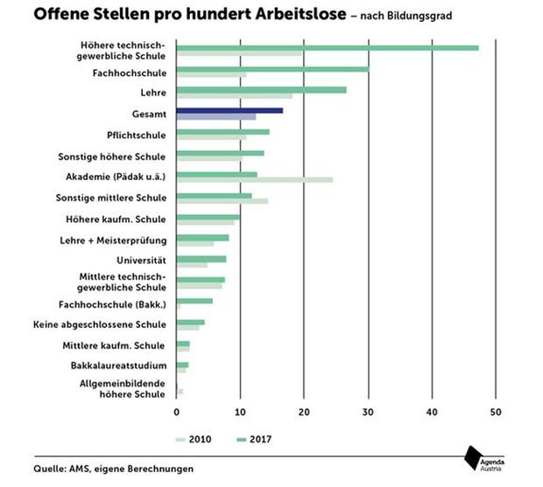

fields, from infrastructure operations to government and administration, from aerospace to medical technology, from digital arts to media – IT experts will be needed in all walks of life. In the race for top jobs, engineers are going fast!

<https://www.google.com/search?q=HTL+Arbeitslosigkeit&hl=de&source=lnms&tbm=isch&sa=X&ved=0ahUKEwjK-KiX0M7eAhWMA8AKHcAIDvUQ_AUIDygC&biw=1920&bih=1094#imgrc=3wb2GFLc3HOmsM>:

Sources:

<https://targetjobs.co.uk/career-sectors/it-and-technology/advice/286189-ten-typical-jobs-graduates-can-do-in-it> [[1](https://targetjobs.co.uk/career-sectors/it-and-technology/advice/286189-ten-typical-jobs-graduates-can-do-in-it%5B1)]

[https://www.technikum-wien.at/htl-ingenieur-bachelor/[2](https://www.technikum-wien.at/htl-ingenieur-bachelor/%5B2)]

<https://derstandard.at/2000084047144/Fachkraeftemangel-Industrie-fordert-dringend-Ausbau-der-HTL-Angebote> [3]